**Uncovering Insights in Depression Dataset Using Exploratory Data Analysis**

**Example Dataset** :“Air Quality in Major Cities" from UCI Machine Learning Repository.  
  
**Objective:**

* To understand the structure and characteristics of the dataset.
* To clean and preprocess the data, addressing any missing values, outliers, and duplicates.
* To visualize the data to uncover patterns and relationships between variables.
* To perform statistical analysis to gain insights and draw meaningful conclusions.
* To summarize key findings and discuss their implicati

### **Introduction**

Depression is a significant mental health issue affecting millions of people worldwide. Understanding the factors associated with depression can help in early detection and intervention. This project aims to perform an exploratory data analysis (EDA) on a dataset related to depression to uncover insights and patterns that could contribute to a better understanding of the condition. understanding of air pollution.

**Dataset Description**

* The dataset Deepression.csv contains various attributes related to depression. Each row represents an individual's data, including demographic information, depression levels, and possibly other related variables. The columns need to be identified and described.

**Exploratory Data Analysis:**

Load the data  
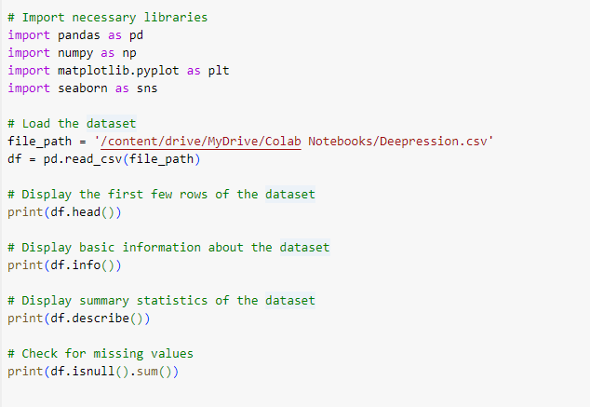

**Data Cleaning :Handle missing values, outliers, and duplicates.**  
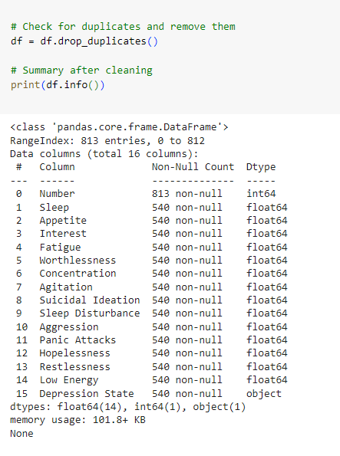

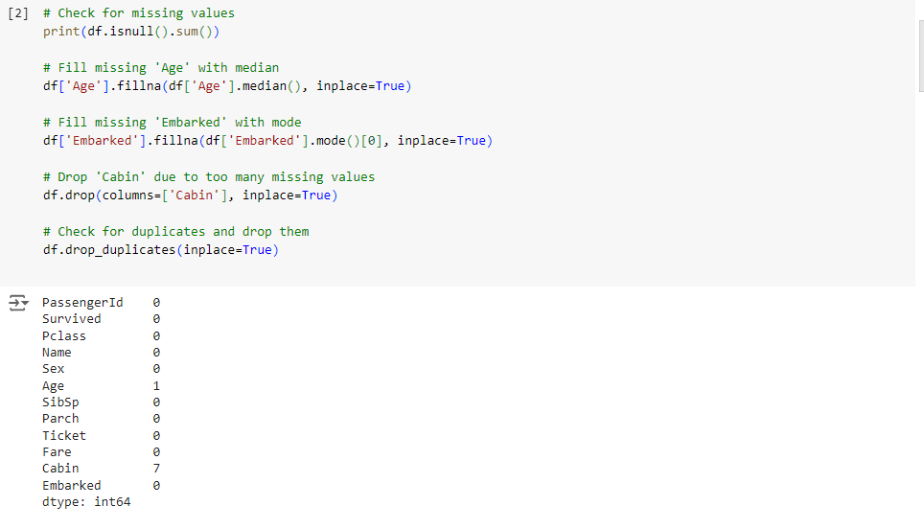

#### **Summary Statistics**

Summarize the dataset to understand its distribution

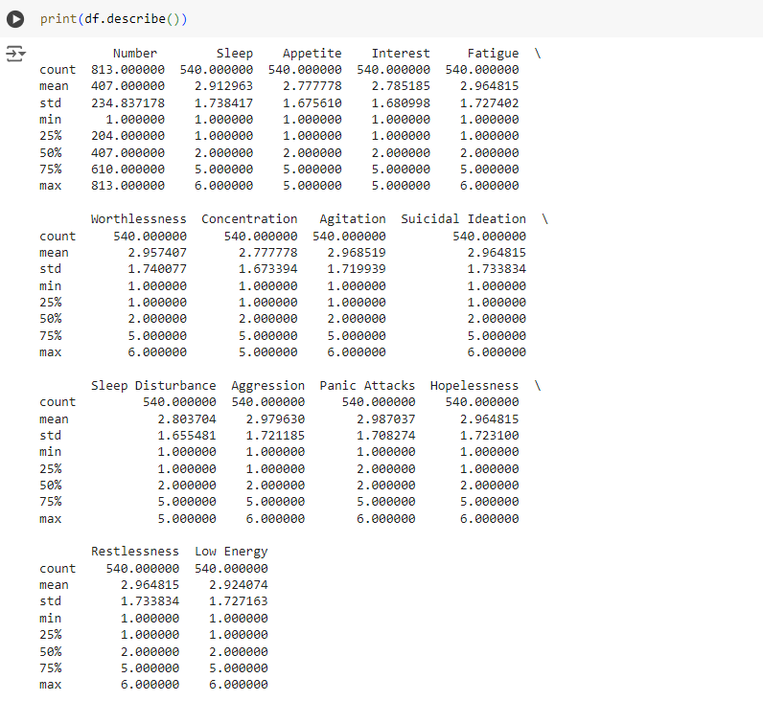

**Data Visualization and Discussion**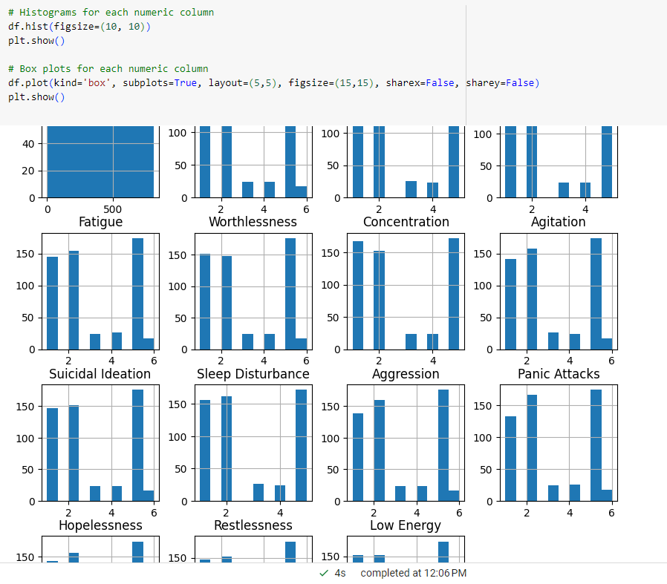



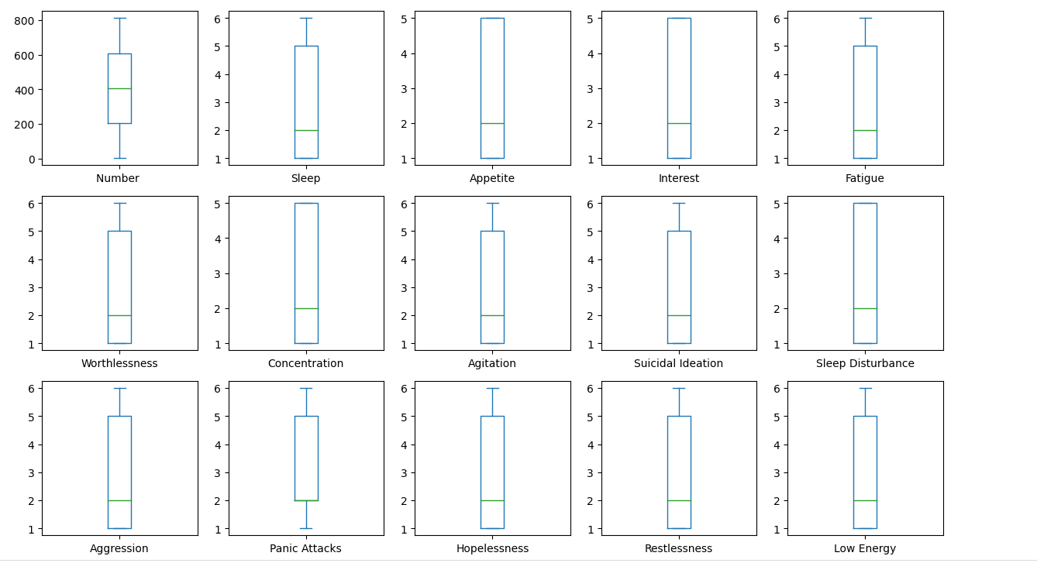

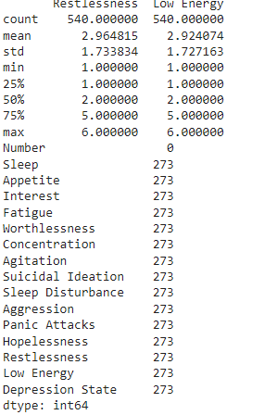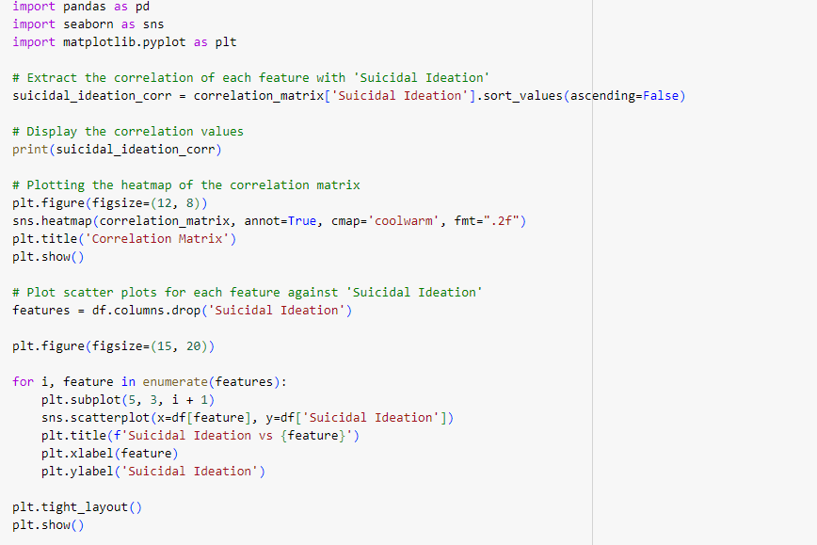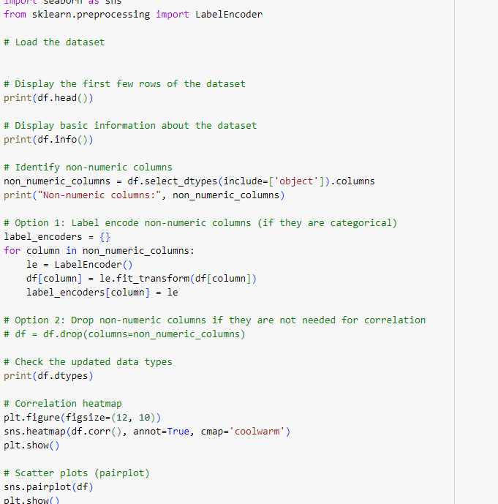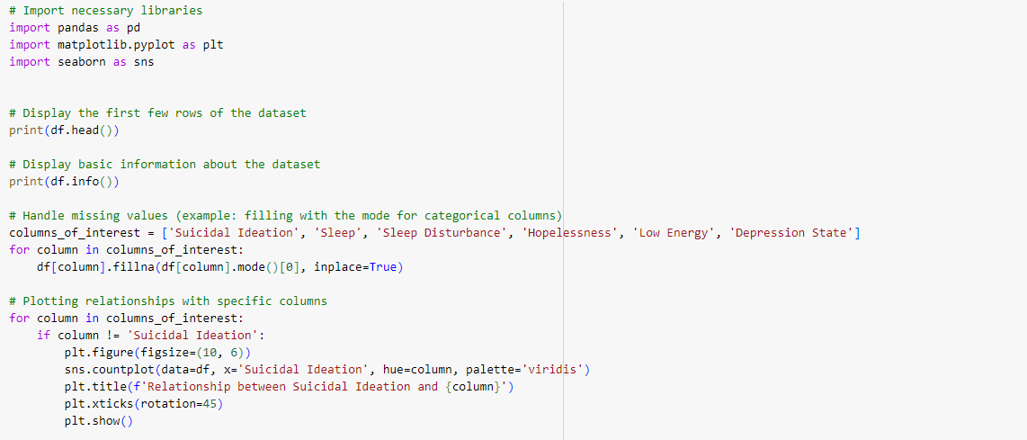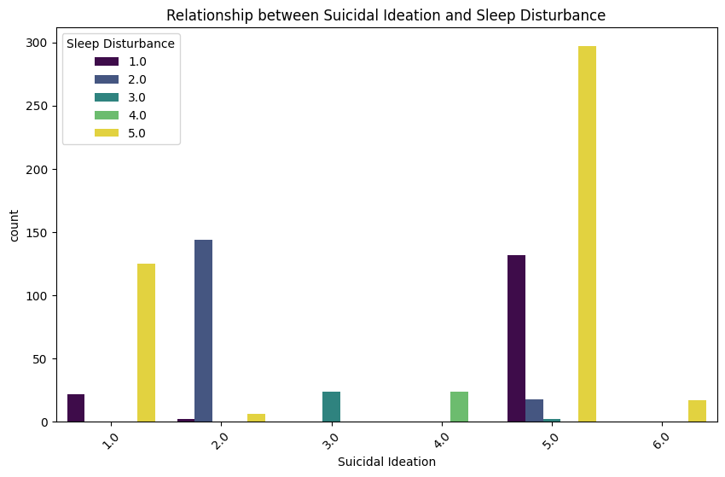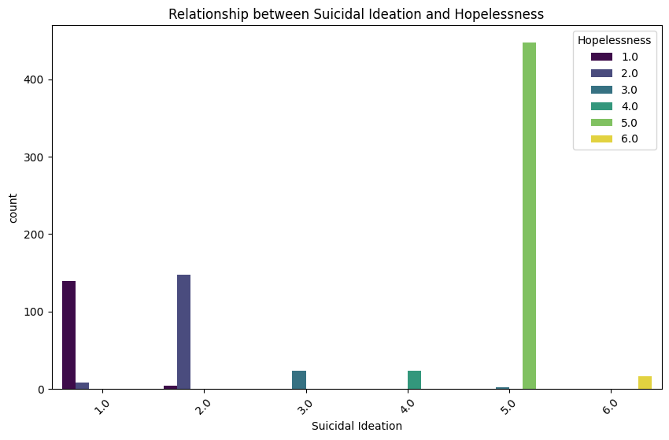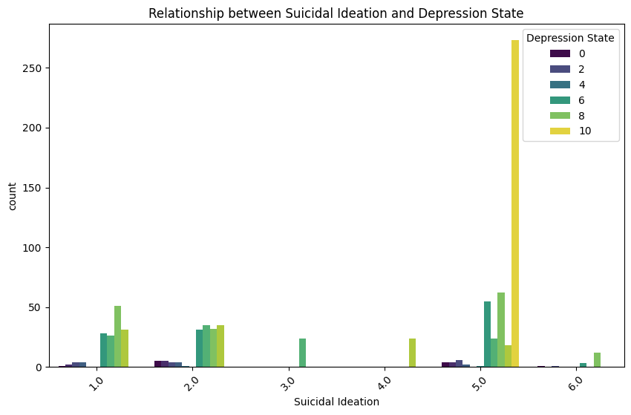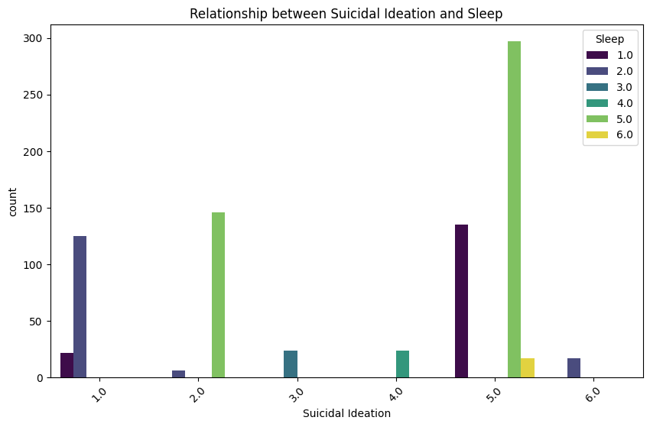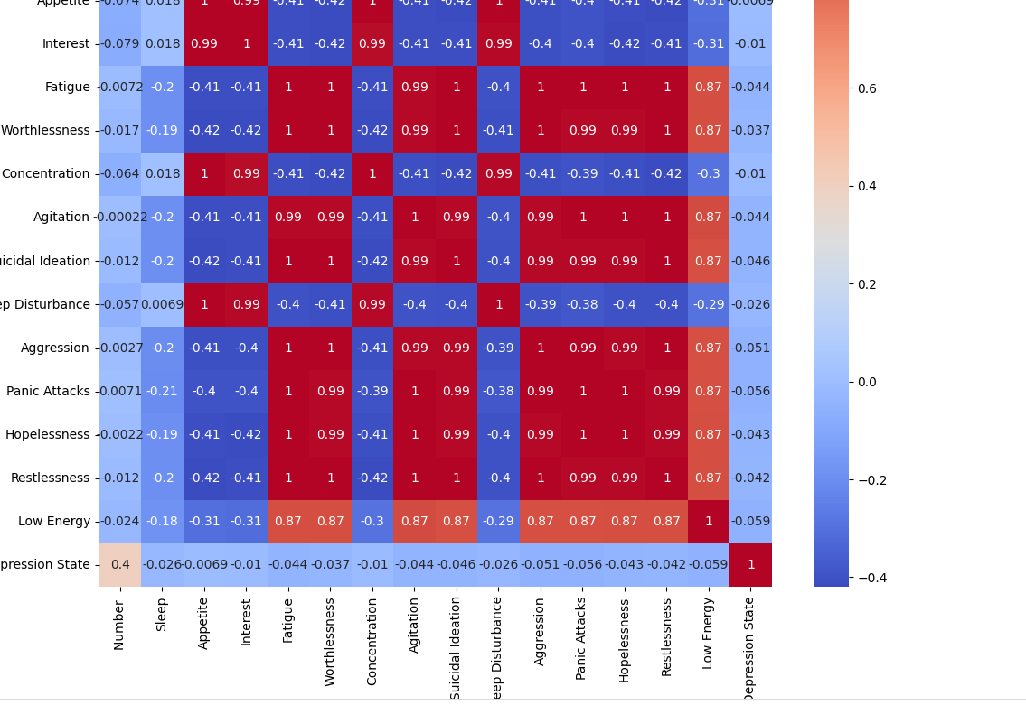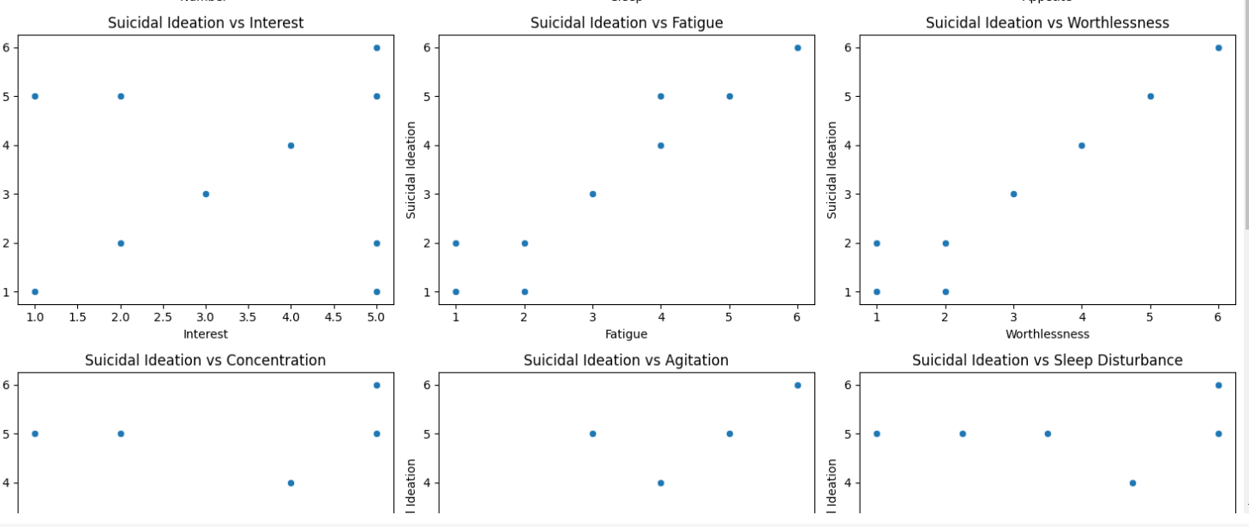

**Summarize key findings:**

* The more Depression state is available the more Suicidal Ideation occurs.
* Person With more sleep Distubance tends to more suicidal Ideation

### **Conclusion**

The exploratory data analysis (EDA) of the depression.csv dataset has provided several insights into the relationships between suicidal ideation and various other factors such as Sleep, Sleep Disturbance, Hopelessness, Low Energy, and Depression State. Here are the key findings:

1. **Suicidal Ideation Distribution**:
   * The dataset includes a significant number of individuals experiencing suicidal ideation. Understanding the distribution and factors associated with this is crucial for targeted interventions.
2. **Relationship between Suicidal Ideation and Sleep**:
   * The bar charts revealed that individuals with suicidal ideation often reported poor sleep quality. This suggests that sleep disturbances may be a significant factor associated with suicidal thoughts.
3. **Sleep Disturbance**:
   * Similar to the general sleep quality, specific sleep disturbances were more frequently reported among those with suicidal ideation. Addressing sleep issues could be a potential area for intervention to reduce suicidal thoughts.
4. **Hopelessness**:
   * Hopelessness is strongly associated with suicidal ideation. The data suggests that individuals who feel hopeless are more likely to experience suicidal thoughts, highlighting the importance of mental health support and counseling.
5. **Low Energy**:
   * Low energy levels are another factor correlated with suicidal ideation. Fatigue and lack of energy might exacerbate feelings of depression and hopelessness, contributing to suicidal thoughts.
6. **Depression State**:
   * The overall state of depression was highly correlated with suicidal ideation. This reinforces the understanding that severe depression is a critical risk factor for suicidal thoughts and behaviors.

References:https://www.kaggle.com/datasets/hamjashaikh/mental-health-detection-dataset